Table of Contents

1.1 Introduction 2

1.2 Procedure Properties 2

1.3 Procedure 2

1.4 Procedure Additional Step Configuration 2

1.5 Procedure Batch Phase Link Groups 2

1.6 Procedure Unit Aliases 2

1.7 Procedure Formula Parameters 2

1.8 Procedure Step Parameters 3

1.8.1 START (No Unit Procedure defined for this Step) 3

1.8.2 UP_BLEND:1 (Unit Procedure: UP_BLEND) 3

1.8.3 UP_COLOR:1 (Unit Procedure: UP_COLOR) 3

1.9 Procedure Procedural Function Chart (PFC) 4

Procedure: PRC_PAINT

## Introduction

The purpose of this document is to provide design details of the PRC_PAINT Procedure for the Customer ABC project.

## Procedure Properties

The following table provides general information about the PRC_PAINT Procedure:

| Property | Value |
| --- | --- |
| Recipe type | PROCEDURE |
| Description |  |
| Product Code and Name | 123 (PAINT) |
| Batch Size (min - max) | 100 (1 - 100) |
| Abstract |  |
| Author | USER1 |
| User | USER1 |
| Time | 19/05/2004 14:53:21 |

Table 1: PRC_PAINT Procedure Properties

## Procedure

The Procedure comprises the following recipe steps and transitions (initial step and termination(s) are highlighted):

| Step Name | Transition(s) | Expression(s) | Next Step(s) |
| --- | --- | --- | --- |
| START | T1 | TRUE | UP_COLOR:1  UP_BLEND:1 |
| UP_BLEND:1 | T2 | 'UP_COLOR:1/BSTATUS' = '$recipe_state:Complete' AND 'UP_BLEND:1/BSTATUS' = '$recipe_state:Complete' | - |
| UP_COLOR:1 | T2 | 'UP_COLOR:1/BSTATUS' = '$recipe_state:Complete' AND 'UP_BLEND:1/BSTATUS' = '$recipe_state:Complete' | - |

Table 2: Procedure Recipe Steps

## Procedure Additional Step Configuration

Following is the additional configuration for steps of the Procedure:

| Name | Unit Alias | Acquire Unit? | Retain Unit? |
| --- | --- | --- | --- |
| UP_BLEND:1 |  | No | No |
| UP_COLOR:1 |  | No | No |

Table 3: Procedure Additional Configuration for Recipe Steps

## Procedure Batch Phase Link Groups

Following are the batch phase link groups set up for the Procedure:

| Name | Description | Phase Invocation(s) |
| --- | --- | --- |
| LINK_COLOR |  | UP_BLEND:1/OP_CHARGE:1/CHG_COLOR:1/  UP_COLOR:1/OP_COLOR:1/DUMP:1/ |

Table 4: Procedure Batch Phase Link Groups

## Procedure Unit Aliases

There are no unit aliases for the PRC_PAINT Procedure.

## Procedure Formula Parameters

The following formula parameters are configured for the PRC_PAINT Procedure:

| Name | Type | Range, Units | Default | Scalable |
| --- | --- | --- | --- | --- |
| AGITATE_TIME | Integer (Input) | 0 - 300 sec | 30 sec | No |
| PRC_BASE_AMT | Real (Input) | 0 - 1000 gal | 150 gal | No |
| PRC_COLOR_AMT | Real (Input) | 0 - 100 gal | 15 gal | No |

Table 5: PRC_PAINT Procedure Unit Aliases

## Procedure Step Parameters

Following are the parameters for the different PRC_PAINT Procedure steps:

### START (No Unit Procedure defined for this Step)

There are no Parameters for this Step.

### UP_BLEND:1 (Unit Procedure: UP_BLEND)

| Step Parameter | Origin | Formula Parameter | Value |
| --- | --- | --- | --- |
| AGITATE_TIME | Deferred | AGITATE_TIME | 30 sec |
| UP_BASE_AMT | Deferred | PRC_BASE_AMT | 150 gal |
| UP_COLOR_AMT | Deferred | PRC_COLOR_AMT | 15 gal |

Table 6: UP_BLEND:1 Step Parameters

### UP_COLOR:1 (Unit Procedure: UP_COLOR)

There are no Parameters for this Step.

## Procedure Procedural Function Chart (PFC)

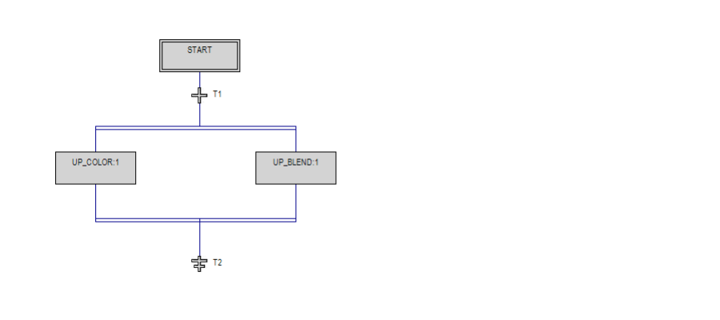

Figure 1: Page 1 of 1